# Initial Installation and Setup

Before we can use the The Reporting App, we must ensure that Microsoft Access 2013 (or newer) is installed on the computer where The Reporting App will be used.

If an earlier version of Access is installed on the computer, it will need to be update to the 2013 version (or newer).

You can also install a free version of Microsoft Access 2013 from the link below.

<http://www.microsoft.com/en-us/download/details.aspx?id=39358>

(download --> choose AccessRuntime x86.exe)

A backup download location is here. <https://www.dropbox.com/s/3xw8nxzwq6fzve9/AccessRuntime_x86_en-us.exe?dl=0>

# Brand New Install

## Download The Reporting App

The Reporting App can be downloaded from the link below.

<https://www.dropbox.com/s/7cd0e5b0jjt728j/SHFB%20Database.zip?dl=0>

If prompted to for a location to save the file, it is suggested to save it to your desktop folder in order to easily find it. Then navigate to where you downloaded the folder

Using your mouse, “Right-Click” the SHFB Database.zip folder you saved and choose *Extract All* option.

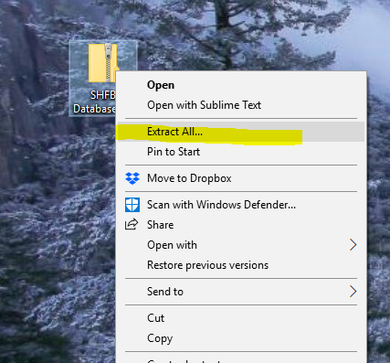

In order for The Reporting App to work properly, the file compressed *ZIP* file that has been downloaded needs to be extracted to a new folder C:\SHFB Database.

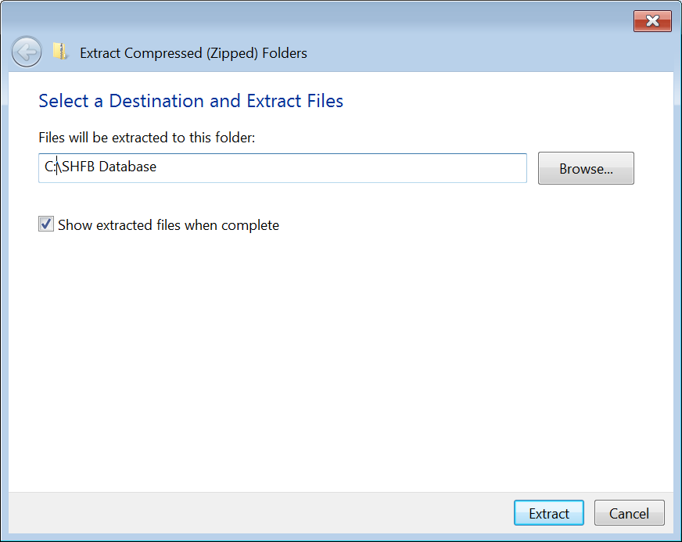

After extraction your folder location should look like the one shown in the image below.

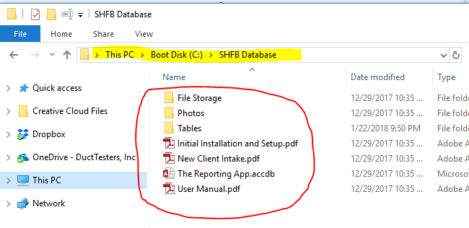

In order to run The Reporting App for the first time, you will need to navigate to

C:\SHFB Database\The Reporting App.accdb

(it is recommended that a shortcut be added to your desktop for easy access later)

## Initial Setup

A simple double click of The Reporting App file will open the program. You should arrive at the Main Menu.

If you receive the yellow security warning as shown in the image below. You must hit the “Enable Content” button before moving on. (enabling macros in the trust center will stop this)

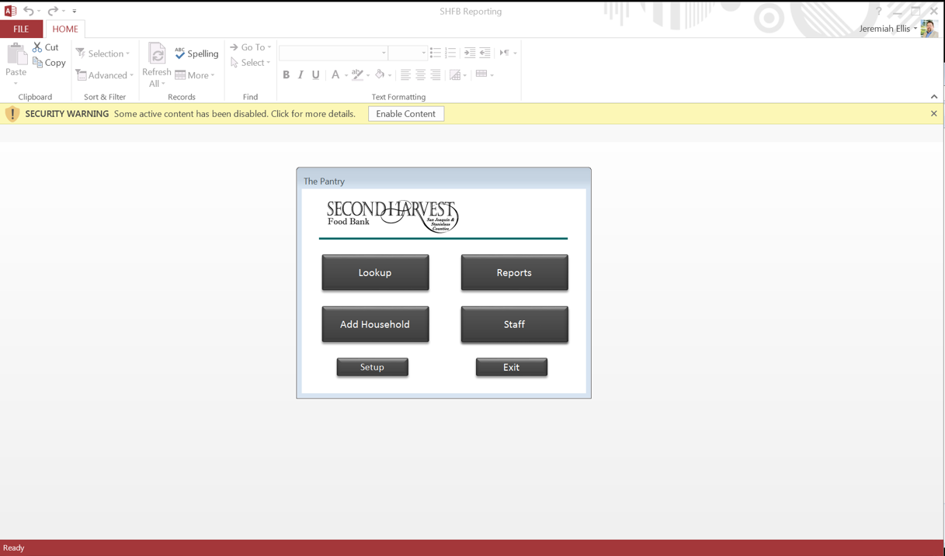

You are no ready to setup you install of The Reporting App. First you must click the “Setup” button on the Main Menu. This screen is where you will enter your Agency Name as it should show on your monthly reporting submittals. This screen will also allow for you to update the income brackets when they are revised.

Version 1.2 or later will allow for users to specify a custom folder location for the tables file. This will be useful for networked environment and allowing more than 1 user to install The Reporting App, but to use the same data tables.

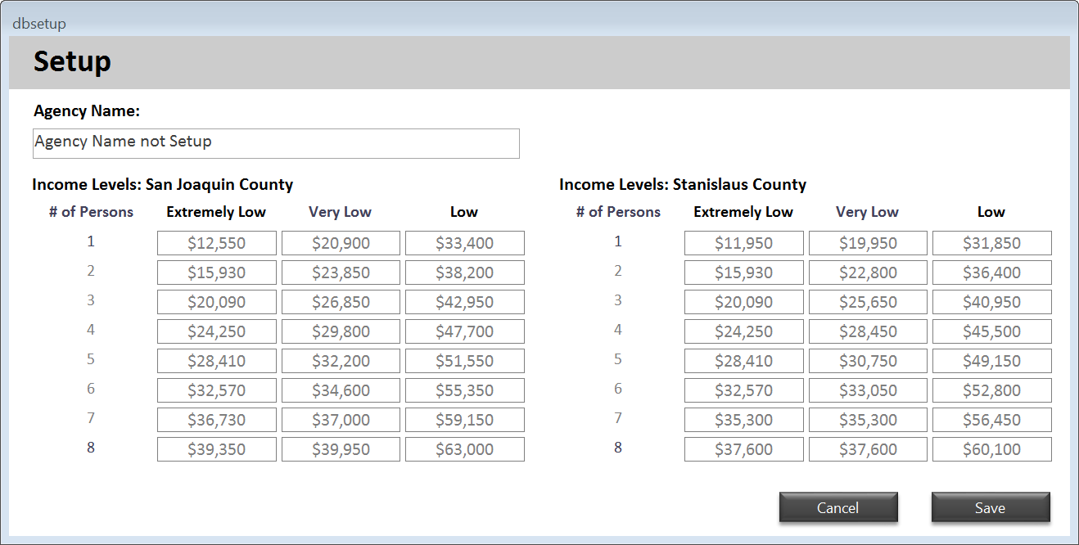

C:\SHFB Database\Tables

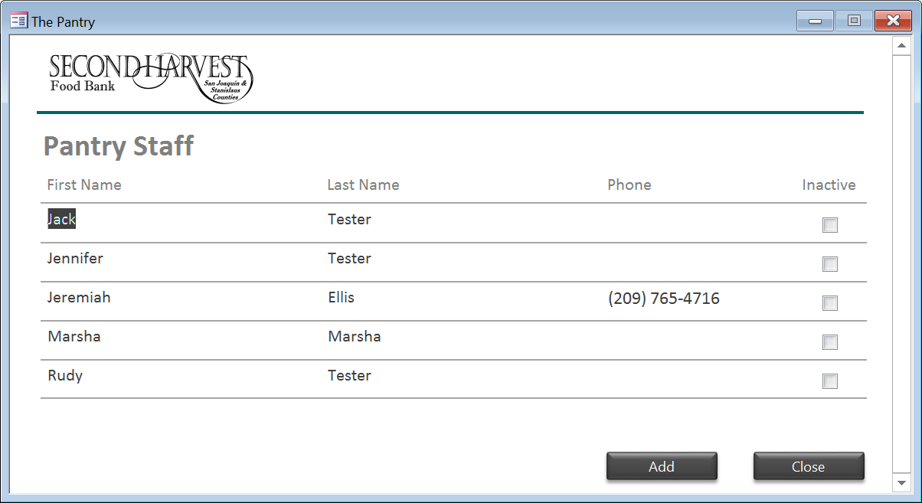The next thing you will to do is setup up staff members. Back on the Main Menu you need to click the “Staff” button. This screen will allow you to add new staff members and mark previous ones as Inactive.

Once you have completed these steps. You are ready to enter your first household

# Updating the App Install

## Download The Reporting App

The Reporting App can be downloaded from the link below.

<https://www.dropbox.com/s/7cd0e5b0jjt728j/SHFB%20Database.zip?dl=0>

If prompted to for a location to save the file, it is suggested to save it to your desktop folder in order to easily find it. Then navigate to where you downloaded the folder.

Double Click the file SHFB Database.zip to open it. You should get a folder view like this image.

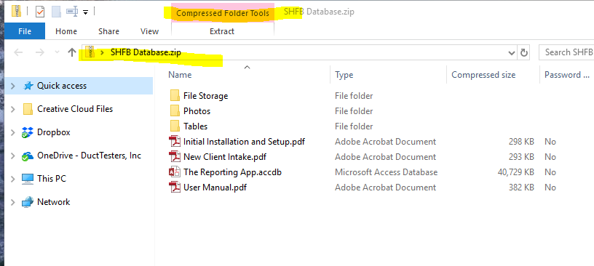

Now Open a 2nd folder window and navigate to the install location of The Reporting App file. That location should be C:\SHFB Database.  
That folder should look like this.

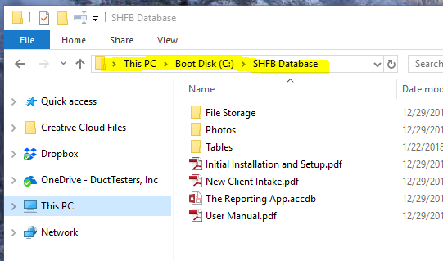

Opening these 2 windows side by side will allow you to copy folders over to update. That should look like this.

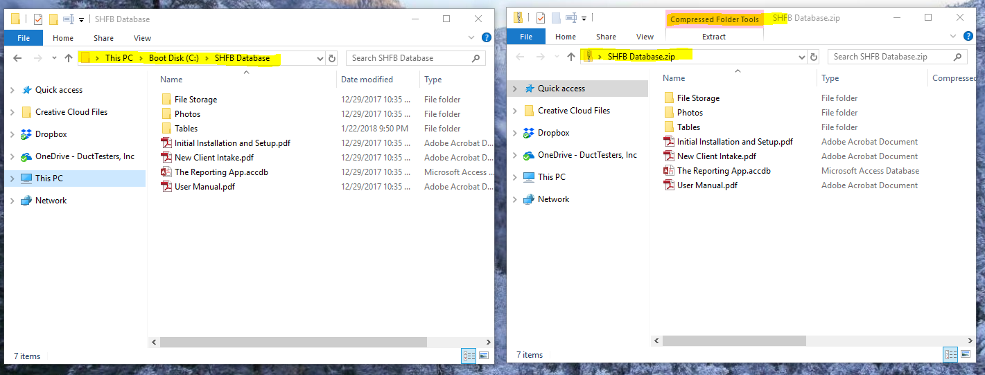

A simple click and drag of the *The Reporting App.accdb* file from the SHFB Database.zip to the C:\SHFB Database folder will update your program.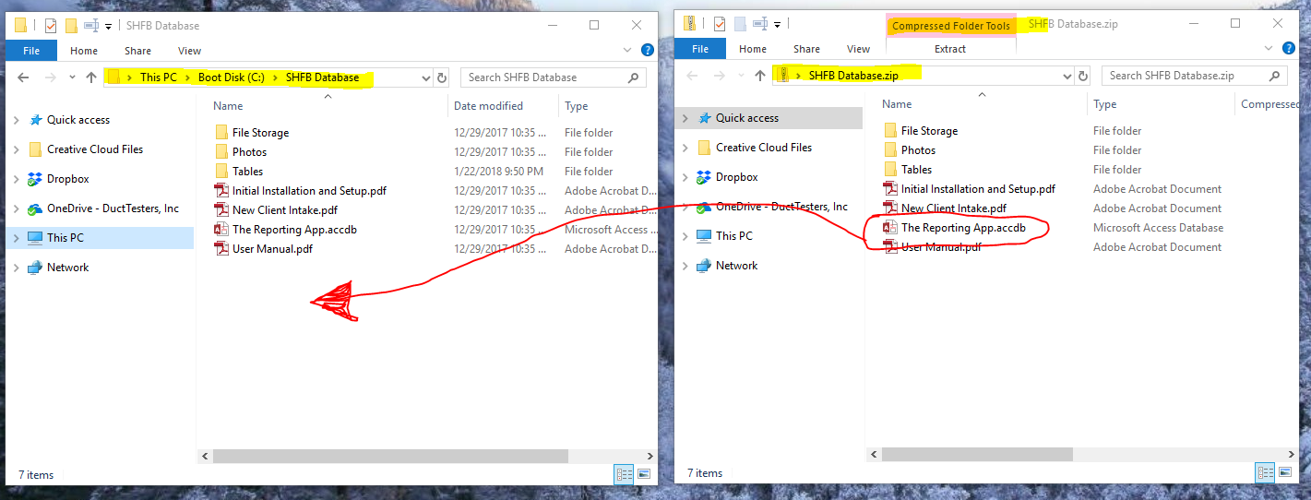

During this operation you will be asked if you want to “Replace or Skip” the file. Choose “Replace”

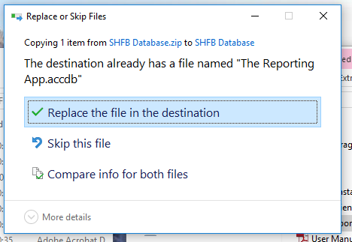

That is it, The Reporting App is update to date.